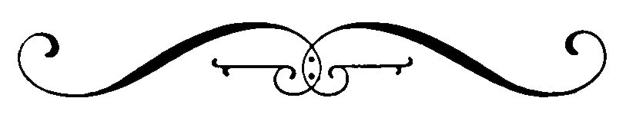
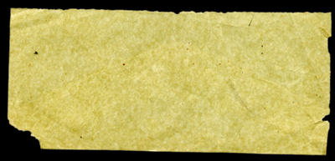
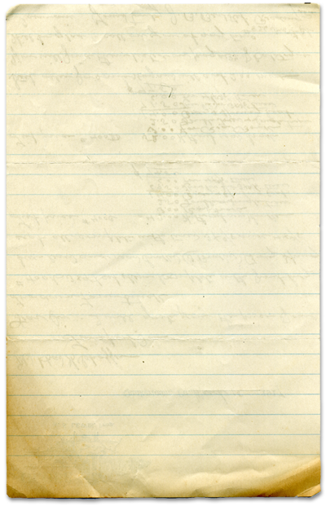
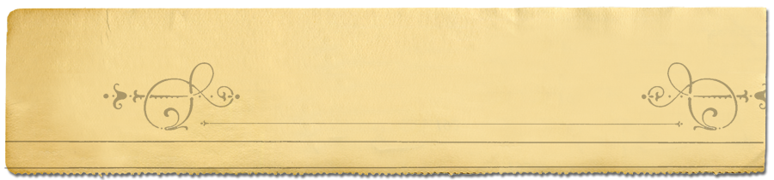
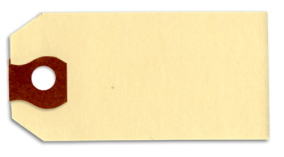
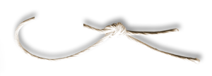
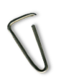
2010/2011 Season summary
May 2011
Carrigaline Badminton Club Won Badminton Irelands ‘Club of the Year 2010/2011’.

Betty Thompson Won Badminton Irelands ‘Volunteer of the Year 2010/2011’
CARRIGALINE BADMINTON CLUB
www.carrigalinebadminton.ie
telephone
021-4371501
Outgoing Committee 2010/2011
President: Anthony O’Loughlin
Secretary / Webmaster: David McGuirk
Treasurer / Juvenile Webmaster: Kieran Coghlan
Fixture Secretary: Mairead Morrissey
Juvenile Officer: Ann Toebes
Juvenile Coaches: Joe Angelini, Martin Hanley, Tony O'Donovan
Public Relations Officer (PRO): Ciaron Malkin
Chairperson: Betty Thompson
Captain: Idoia Murphy

Committee Members:
Joe Angelini, Arjan Toebes, Ita Daly, Tricia O’Herlihy, Philip Hogan

Selection Committee:
Idoia Murphy, Betty Thompson, Joe Angelini, Ciaron Malkin, Ita Daly
2010/2011 Team results
Team  (Senior and Juvenile) | Event | Result
Division 1B Mixed | All-Ireland Finals | Runner-Up
Division 1B Mixed | Munster Div 1B Finals | Winner
Division 1B Mixed | League | Winner
Division 1B Mixed | Championship Cup | Winner
Division 1B Mixed | Handicap Cup | Winner
Division 2 Mixed | Munster Div 2 Finals | Runner-Up
Division 2 Mixed | League | Runner-Up
Division 2 Mixed | Handicap Cup | Winner
Division 2 Mens | League | Runner-Up
Division 2 Ladies | League | Winner
Division 3 Mixed | Munster Div 3 Finals | Runner-Up
Division 3 Mixed | League | Winner
Division 3 Mixed | Championship Cup | Winner
Division 3 Mens | Handicap Cup | Runner-Up
Division 6 Mens | League | Runner-Up
Division 6 Mens | Handicap Cup | Winner
Novice Mens | League | Runner-Up
Under 17 Mixed | League | Winner
Under 17 Boys | League | Winner
Under 15 Boys | League | Runner-Up
Under 13 Mixed | League | Semi-Finalist
Cork Individual and Munster Team Results
Cork Co C’ships Individual Senior | Event | Result
Conor Hayes | Division 1 Mens Singles | Winner
Conor Hayes | Division 1 Mens Doubles | Winner
Conor Hayes | Division 1 Mixed Doubles | Runner-Up
Paul Foy | Division 1 Mens Singles | Runner-Up
Paul Foy | Division 1 Mens Doubles | Winner
Patricia O’Herlihy | Division 1 Ladies Doubles | Winner
Clodagh Fitzgerald | Division 1 Ladies Doubles | Winner
Caroline Hayes | Division 1 Mixed Doubles | Runner-Up
Mairead Morrissey | Division 2 Ladies Singles | Winner
Mairead Morrissey | Division 3 Ladies Singles | Winner
Ali Zain | Division 2 Mens Singles | Winner
Kevin Moynihan | Division 2 Mens Singles | Runner-Up
Lucy Kearns | Division 2 Ladies Doubles | Winner
Freida Kearns / Collins | Division 2 Ladies Doubles | Winner
Gavin Chambers | Division 3 Mens Singles | Winner
Gavin Chambers | Division 3 Mens Doubles | Winner
David McGuirk | Division 3 Mens Singles | Runner-Up
David McGuirk | Division 3 Mens Doubles | Winner
Chris Kelleher | Division 3 Mixed Doubles | Runner-Up
Julie Ahern | Division 3 Mixed Doubles | Runner-Up
Munster Inter-County Team Senior | Member | Result
Class 3 Team | Conor Hayes | Winner
Class 3 Team | Paul Foy | Winner
Class 3 Team | Michelle Hayes | Winner
Class 3 Team | Patricia O’Herlihy | Winner
Class 3 Team | Clodagh Fitzgerald | Winner
Class 4 Team A | Patricia O’Herlihy | Winner
Class 4 Team A | Clodagh Fitzgerald | Winner
Class 4 Team A | Freida Kearns / Collins | Winner
Class 4 Team A | Lucy Kearns | Winner
Class 4 Team A | Conor Hayes | Winner
Class 4 Team A | David Collins | Winner
Class 4 Team B | Ali Zain | Team Member
Class 4 Team B | Ita Daly | Team Member
Class 4 Team B | Julie Ahern | Team Member
Class 5 Team | Mairead Morrissey | Runner-Up
Class 5 Team | David McGuirk | Runner-Up
Brewster Cup | Ali Zain | Winner
Brewster Cup | Mairead Morrissey | Winner
Brewster Cup | Freida Kearns / Collins | Winner
Brewster Cup | Patricia O’Herlihy | Winner
Butterfield Cup | Paul Foy | Winner
Butterfield Cup | Caroline Hayes | Winner
Butterfield Cup | Michelle Hayes | Winner
Munster Championships  Senior | Competition | Event | Result
Conor Hayes | Munster C’ships | Div 1 Mens Singles | R-Up
Ali Zain | Munster C’ships | Div 2 Mens Singles | R-Up
Mairead Morrissey | Munster C’ships | Div 2 Ladies Singles | R-Up
Conor Hayes | Munster C’ships | Div 1 Mens Doubles | R-Up
Paul Foy | Munster C’ships | Div 1 Mens Doubles | R-Up
Gavin Chambers | Munster C’ships | Div 3 Mens Doubles | R-Up
David McGuirk | Munster C’ships | Div 3 Mens Doubles | R-Up
Conor Hayes | Munster Senior 2 C’ships | Mens Singles | Winner
Conor Hayes | Munster Senior 2 C’ships | Mixed Doubles | R-Up
Patricia O’Herlihy | Munster Junior C’ships | Ladies Doubles | Winner
Clodagh Fitzgerald | Munster Junior C’ships | Ladies Doubles | Winner
Freida Kearns / Collins | Munster Junior C’ships | Ladies Doubles | R-Up
Lucy Kearns | Munster Junior C’ships | Ladies Doubles | R-Up
Ciaron Malkin | Munster Graduates | Mens Doubles | Winner
Mairead Morrissey | Munster Graduates | Ladies Singles | Winner
Mairead Morrissey | Munster Graduates | Ladies Doubles | R-Up
Ita Daly | Munster Graduates | Ladies Doubles | R-Up
Mairead Morrissey | Munster Grade 3 | Ladies Singles | Winner
Mairead Morrissey | Munster Grade 3 | Ladies Doubles | Winner
Julie Ahern | Munster Grade 3 | Ladies Doubles | Winner
Chris Kelleher | Munster Grade 3 | Mens Singles | Winner
Chris Kelleher | Munster Grade 3 | Mixed Doubles | R-Up
Julie Ahern | Munster Grade 3 | Mixed Doubles | R-Up
Munster Championships Senior Results

Cork Co C'ships Individual Juvenile | Event | Result
Craig O’Byrne | Under 11 Division 1 Boys Doubles Plate | Winner
Adam Barry | Under 11 Division 1 Boys Doubles Plate | Winner
Ronan Quirke | Under 11 Division 1 Mixed Doubles | Runner-Up
Eadaoin Coghlan | Under 11 Division 1 Mixed Doubles | Runner-Up
Danu Ní Thuama | Under 11 Division 1 Girls Doubles | Runner-Up
Eadaoin Coghlan | Under 11 Division 1 Girls Doubles | Runner-Up
Eadaoin Coghlan | Under 11 Division 1 Girls Singles | Runner-Up
Caoimhe Coghlan | Under 13 Division 1 Girls Singles | Winner
Caoimhe Coghlan | Under 13 Division 1 Girls Doubles | Runner-Up
Liam Toebes | Under 13 Division 2 Boys Singles | Winner
Liam Toebes | Under 13 Division 2 Boys Doubles | Winner
Frank Toebes | Under 13 Division 2 Boys Doubles | Winner
Andrew Dunlea | Under 15 Division 2 Boys Singles | Winner
Chris Kelleher | Under 17 Division 1 Boys Singles | Winner
David O’Donovan | Under 17 Division 1 Boys Singles | Runner-Up
Chris Kelleher | Under 17 Division 1 Boys Doubles | Winner
David O’Donovan | Under 17 Division 1 Boys Doubles | Winner
Chris Kelleher | Under 17 Division 1 Mixed Doubles | Winner
Orla Coghlan | Under 17 Division 1 Mixed Doubles | Winner
Orla Coghlan | Under 17 Division 1 Ladies Doubles | Runner-Up
Munster Championships Juvenile | Competition | Result
Chris Kelleher | Under 17 Division 1 Boys Singles | Winner
Chris Kelleher | Under 17 Division 1 Boys Doubles | Runner-Up
Chris Kelleher | Under 17 Division 1 Mixed Doubles | Runner-Up
Caoimhe Coghlan | Under 15 Division 1 Girls Singles Plate | Runner-Up
Liam Toebes | Under 13 Division 2 Boys Doubles | Runner-Up
Liam Toebes | Under 13 Division 2 Mixed Doubles | Runner-Up
Liadh Whelan | Under 13 Division 2 Mixed Doubles | Runner-Up
Inter-County Team Juvenile | Team | Result
Chris Kelleher | Cork Under 17 Team First Round | Winner
David O’Donovan | Cork Under 17 Team First Round | Winner
Eadaoin Coghlan | Cork Under 11 Team First Round | Winner
Caoimhe Coghlan | Cork Under 13 Team First Round | Runner-Up
Orla Coghlan | Cork Under 17 Team Second Round | Runner-Up
Caoimhe Coghlan | Munster Under 13 Team | Third
Juvenile Results
Summary of 2010/2011 Season
New gravel was laid out in the carpark which was used to fill in all the pot-holes: Nearly a dozen people turned up to help out on the day, thanks to everyone involved.
New light meters were installed in the hall which show the number of minutes remaining. Thanks to Ciaron for purchasing the meters & Joe and Brendan for installing them.
A new boiler and six radiators were installed in the kitchen, shower and viewing areas: Thanks to Idoia, Philip and Joe for arranging the quote and installation.
A leak in the roof above Karwig wines was fixed. Thanks to Joe for arranging the fix & also the fitting of the automatic door closure which will help reduce the draft.
The old cleaner finished up and a new cleaner has started which people might see around the hall. Thanks to Idoia and Betty for their continued work with the cleaner and the general upkeep of the hall.
Bright blue foam padding was installed around all the girders in the hall. Thanks to Philip for purchasing it and to Joe and Ron for putting it up.
A new sign was placed at the end of the road. Thanks to Mairead for organizing the sign.
Fly catchers were installed in the canteen which has reduced the number of flies in the area. Thanks to Ann Toebes.
A Christmas Party was held in the Carrigaline Court Hotel. It was a great night and thanks to Trish, Betty and Idoia for organizing the event.
The committee arranged for at least one committee member to attend each club night to help out with the organization. Thanks to all members who gave up their time to come along and help out on club nights.
Joe, Martin, Ron, and Tony O’Donovan are the main volunteers for Juvenile coaching and supervision. Some of them have been doing that for over 20 years, so we would welcome any new faces that are willing to take over for the coming season as some, or all of them will be stepping down.
A number of juvenile match reports were included in the Southern Star. Thanks to Kieran Coghlan, Ann Toebes and Tony O’Donovan for writing the reports and forwarding them to the Southern Star.
To try to reduce costs for social members, Carrigaline Badminton Club approached Badminton Ireland, Munster Badminton and Cork County Badminton requesting to know why social members are required to pay affiliation fees to Munster Badminton and Cork County badminton when they don’t play in any competitions. No formal response has been received and the club will consider whether such payment will be forwarded next season.
The committee also approached Cork County to see if they would subsidize training of selected coaches in the club. CCBA are currently looking in to this option.
A number of club competitions were run during the season including an end of season tournament. Thanks to Betty, Idoia and Joe for organizing the tournaments.

